UI & UX DESIGN LABORATORY

Lab Manual for III Year B.Tech (IT) Students
As per the ANNA UNIVERSITY R-2021 Syllabus

Lab Manual
Observation Note Book
Short Procedures
Viva-Voce Q & A

Authors
Mrs. G.Gayathri, M.E., (PhD).,
Mrs. G.Kanmani, M.E., (PhD).,
Mrs. B.Sasikala, M.E.,
Mrs. A.Santhi, M.E.,

© Copyright, Authors all rights reserved. No part of this book may be reproduced, stored in a retrieval system, or transmitted, in any form by any means, electronic, manual, photocopying, recording or otherwise, without the prior written consent of its Authors.

Royal Book Publishing

Book Title | UI & UX Design Laboratory
Book Size | 8.5 * 11 Inch
Paper | Natural Shade
Publisher | Royal Book Publishing 21/11, K M Nagar, Ayodhiyapatinam, Salem.  Tamil Nadu-636103 Cell:+91 7598141199  Email: contact@royalbookpublishing.com  Website: www.royalbookpublishing.com


ISBN Assigned by Raja Ram Mohun Roy National Agency for ISBN, New Delhi – 110066 (India)

ISBN:

UI & UX DESIGN LABORATORY

Lab Manual for III Year B.Tech (IT) Students
As per the ANNA UNIVERSITY Syllabus

Lab Manual
Observation Note Book
Short Procedures
Viva-Voce Q

Mrs. G.Gayathri, M.E., (PhD).
Assistant Professor/IT
R P Sarathy Institute of Technology,

Poosaripatty, Salem-636305
Mrs. G.Kanmani, M.E., (PhD).,
Assistant Professor/IT
R P Sarathy Institute of Technology,
Poosaripatty, Salem-636305.

Mrs. G.V. Kanimozhi, M.E
Assistant Professor/IT
R P Sarathy Institute of Technology,
Poosaripatty, Salem-636305.

Mrs. B. Sasikala, M.E.,
Assistant Professor/IT
R P Sarathy Institute of Technology,
Poosaripatty, Salem-636305.

PREFACE
This book on “COMPUTER NETWORKS LABARATORY” covers the complete syllabus prescribed by the Anna University, Chennai for the fifth semester B.Tech(IT).To acquire practical knowledge of network protocols and communication, the following experiments are crafted to offer hands-on experience and foster a deeper understanding.

In the pursuit of gaining practical insights into network protocols and communication, the following experiments have been formulated to provide hands-on experience and deepen understanding. These exercises are designed for educational purposes, aiming to enhance proficiency in networking concepts and programming skills.

These experiments are designed to provide a practical foundation in networking and programming, with an emphasis on responsible and ethical engagement throughout the learning process.

We are grateful to publishers for making us to publish this book. We sincerely acknowledge our colleagues and family members for their support.
The students are advised to go through the procedures given in the book at least once, in order to get full benefit out of this book.

Wish you all success in your career. “May God bless you all”

We are thankful to our Chairman, members of R P Sarathy Institute of Technology for their constant encouragement in bringing out this book.

Mrs. G.Gayathri, M.E., (PhD).,
Mrs. G.Kanmani, M.E., (PhD).,
Mrs. B.Sasikala, M.E.,
Mrs. A.Santhi, M.E.,

ACKNOWLEDGEMENTS

We owe our deep gratitude to our Founder, Thiru. R.P.Sarathy Ayya for his blessings to complete the book successfully.

We are thankful to and fortunate enough to get constant encouragement, support and guideline from Chairman Mr.B.Nitish Harihar, Pro-Chairman Mrs.Aishwarya Nitish and Vice-Chairman & Secretary, Thiru.G.Prabakaran.

We would not forget to remember our Principal. Dr. V. Munusami for his constant assistance in preparing this book. We also thank our publisher for bringing out this book.

PROGRAM EDUCATIONAL OBJECTIVES :
PEO1: To ensure graduates will be proficient in utilizing the fundamental knowledge of basic sciences, mathematics and Information Technology for the applications relevant to various streams of Engineering and Technology.
PEO2: To enrich graduates with the core competencies necessary for applying knowledge of computers and telecommunications equipment to store, retrieve, transmit, manipulate and analyze data in the context of business enterprise.
PEO3: To enable graduates to think logically, pursue lifelong learning and will have the capacity to understand technical issues related to computing systems and to design optimal solutions.
PEO4: To enable graduates to develop hardware and software systems by understanding the importance of social, business and environmental needs in the human context.
PEO5: To enable graduates to gain employment in organizations and establish themselves as professionals by applying their technical skills to solve real world problems and meet the diversified needs of industry, academia and research.

PROGRAMME OUTCOMES:
  - Engineering Graduates will be able to:
1.Engineering knowledge: Apply the knowledge of mathematics, science, engineering fundamentals, and an engineering specialization to the solution of complex engineering problems.
2. Problem analysis: Identify, formulate, review research literature, and analyze complex engineering problems reaching substantiated conclusions using first principles of mathematics, natural sciences, and engineering sciences.
3. Design/development of solutions: Design solutions for complex engineering problems and design system components or processes that meet the specified needs with appropriate consideration for the public health and safety, and the cultural, societal, and environmental considerations.
4. Conduct investigations of complex problems: Use research-based knowledge and research methods including design of experiments, analysis and interpretation of data, and synthesis of the information to provide valid conclusions.

5. Modern tool usage: Create, select, and apply appropriate techniques, resources, and modern engineering and IT tools including prediction and modeling to complex engineering activities with an understanding of the limitations.
6. The engineer and society: Apply reasoning informed by the contextual knowledge to assess societal, health, safety, legal and cultural issues and the consequent responsibilities relevant to the professional engineering practice.
7. Environment and sustainability: Understand the impact of the professional engineering solutions in societal and environmental contexts, and demonstrate the knowledge of, and need for sustainable development.
8. Ethics: Apply ethical principles and commit to professional ethics and responsibilities and norms of the engineering practice.
9. Individual and team work: Function effectively as an individual, and as a member or leader in diverse teams, and in multidisciplinary settings.
10. Communication: Communicate effectively on complex engineering activities with the engineering community and with society at large, such as, being able to comprehend and write effective reports and design documentation, make effective presentations, and give and receive clear instructions.
11. Project management and finance: Demonstrate knowledge and understanding of the engineering and management principles and apply these to one’s own work, as a member and leader in a team, to manage projects and in multidisciplinary environments.
12. Life-long learning: Recognize the need for, and have the preparation and ability to engage in independent and life-long learning in the broadest context of technological change.

PROGRAM SPECIFIC OBJECTIVES (PSOs):
  - To create, select, and apply appropriate techniques, resources, modern engineering and IT tools including prediction and modelling to complex engineering activities with an understanding of the limitations.
  - To manage complex IT projects with consideration of the human, financial, ethical and environmental factors and an understanding of risk management processes, and operational and policy implications.

GENERAL INSTRUCTIONS FOR LABORATORY CLASSES
- Each person may only use one computer at a time.
- Computers and peripherals are not to be moved or reconfigured without approval of Lab and Classrooms staff.
- For installation of any software should do contact the Lab support team.
- Drinks are allowed, as long as they are in no-spill containers.
- Behavior and activities that disturb other users or disrupt the operations of the lab are not allowed.
- Always keep silence in the lab.
- Unless and until needed,do not boot any system in the lab.
- Don't move or shift the C.P.U. ...
- Do not play with computer peripherals and wires.

FOR EXAMPLE
- Aim of the experiment
- Algorithms
- Programme
- Output
- Results

FACULTY – INCHARGE.
- Begin every experiment on a NEW PAGE.
- The report should be completed in all respects and submitted in the very NEXT CLASS.
- Write the NAME OF THE EXPERIMENT in capital letters on the top of the page.
- Experiment number with date should be written at the top left hand corner.
- Be PATIENT, STEADY, SYSTEMATIC and REGULAR.

INDEX
S. NO | DATE | NAME OF THE EXPERIMENT | PAGE NO | MARKS | SIGNATURE OF THE  STAFF
1 |  | Designing a Responsive layout for an societal application | 13
2 |  | Exploring various UI Interaction Patterns | 18
3 |  | Developing an interface with proper UI Style Guides | 28
4 |  | Developing Wireflow diagram for application using open-source software | 35
5 |  | Exploring various open source collaborative interface Platform | 38
6 |  | Hands on Design Thinking Process for a new product | 40
7 |  | Brainstorming feature for proposed product | 43
8 |  | Defining the Look and Feel of the new project | 45
9 |  | Create a Sample Pattern Library for that product  (Mood board, Fonts, Colors based on UI principles) | 48
10 |  | Identify a customer problem to solve | 51
11 |  | Conduct end-to-end user research - User research, creating personas, Ideation process (User stories,  Scenarios), Flow diagrams, Flow Mapping | 55
12 |  | Sketch, design with popular tool and build a prototype and perform usability testing and identify improvements | 58

OBJECTIVES:
  - To understand the concept of layering in networks.
  - To know the functions of protocols of each layer of TCP/IP protocol suite.
  - To visualize the end-to-end flow of information.
  - To learn the functions of network layer and the various routing protocol
  - familiarize the functions and protocols of the Transport layer

After the completion of this course, students should be able to [Blooms Taxonomy]

CCS370.1 | Understand the basics for UI & UX design
CCS370.2 | Evaluating UX design of any product application
CCS370.3 | Demonstrating UX skills in product development.
CCS370.4 | Implementing sketching principles
CCS370.5 | Creating wire frames and proto types.

Course Code: CCS370

Expected Course outcome and Program Outcome Mapping
 |  | Contribution 1: low, 2 - medium, 3 - high, ‘-“- no correlation
CO/PO | PO  1 | PO  2 | PO  3 | PO  4 | PO  5 | PO  6 | PO  7 | PO  8 | PO  9 | PO  10 | PO  11 | PO  12 | PS  O1 | PS  O2 | PS  O3
CCS370.1 | 3 | 1 | 1 | 3 | 1 | - | - | - | 3 | 3 | 2 | 1 | 3 | 3 | 1
CCS370.2 | 2 | 3 | 1 | 3 | 2 | - | - | - | 1 | 2 | 2 | 2 | 1 | 2 | 2
CCS370.3 | 1 | 3 | 3 | 2 | 2 | - | - | - | 2 | 3 | 1 | 2 | 1 | 3 | 3
CCS370.4 | 1 | 2 | 3 | 3 | 1 | - | - | - | 3 | 2 | 1 | 3 | 3 | 3 | 3
CCS370.5 | 1 | 2 | 3 | 2 | 1 | - | - | - | 2 | 1 | 1 | 1 | 3 | 2 | 2
AVG | 1.6 | 2.2 | 2.2 | 2.6 | 1.4 | - | - | - | 2.2 | 2.2 | 1.4 | 1.8 | 2.2 | 2.6 | 2.2

EX.NO:1 DATE: | Designing a Responsive layout for an societal application

AIM:

The aim is to design a responsive layout for a societal application that provides users with features to connect, share, and collaborate for the betterment of society. The layout should adapt to various screen sizes and devices to ensure an optimal user experience.

PROGRAM:
<!DOCTYPE html>
<html lang="en">
<head>
<meta charset="UTF-8">
<meta name="viewport" content="width=device-width, initial-scale=1.0">
<title>Societal Application</title>
<link rel="stylesheet" href="styles.css">
</head>
<body>
<header>
<h1>Societal Application</h1>
</header>
<nav>
<ul>
<li><a href="#">Home</a></li>
<li><a href="#">About</a></li>
<li><a href="#">Services</a></li>
<li><a href="#">Contact</a></li>
</ul>
</nav>
<section class="main-content">
<article>
<h2>Welcome to Societal Application</h2>
<p>This is a place where people connect, share, and collaborate for a better society.</p>
</article>
</section>
<aside>
<h2>Latest Updates</h2>
<p>Stay tuned for the latest news and events in your community.</p>
</aside>
<footer>
<p>&copy; 2024 Societal Application. All rights reserved.</p>
</footer>
</body>
</html>
CSS:- /* Reset CSS */
* { margin: 0; padding: 0; box-sizing: border-box;
}
body {
font-family: Arial, sans-serif;
}
header { background-color: #333;
color: #fff; text-align: center; padding: 20px 0;
}
nav { background-color: #555;
color: #fff;
padding: 10px;
}
nav ul { list-style-type: none; text-align: center;
}
nav ul li { display: inline; margin-right: 10px;
}
nav ul li a { color: #fff;
text-decoration: none;
}
.main-content { margin: 20px;
}
article {
background-color: #f9f9f9; padding: 20px;
}
aside { background-color: #ddd; padding: 20px;
}
footer {
background-color: #333;
color: #fff; text-align: center; padding: 10px 0;
}

OUTPUT:
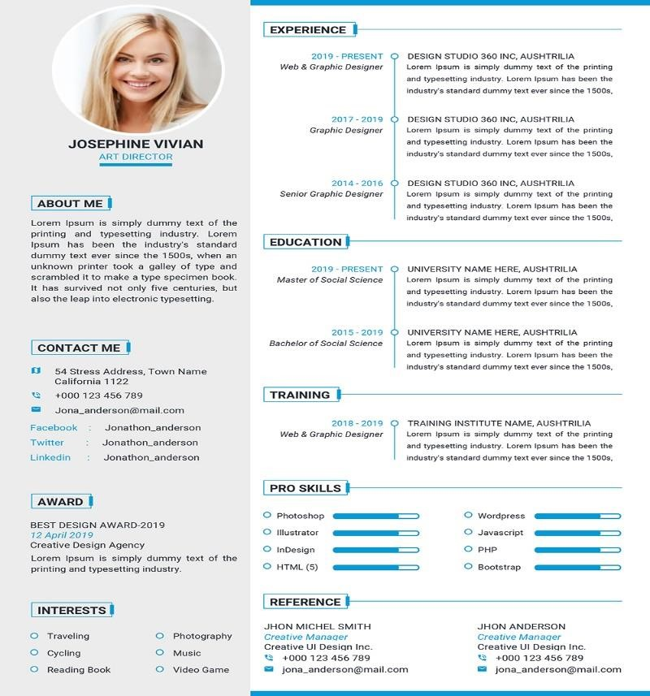

RESULT:
Thus the UI/UX program of Responsive layout is verified and executed successfully.

EX.NO:2 DATE: | Exploring various UI Interaction Patterns

AIM:

Exploring various UI Interaction Patterns Creating a program to explore various UI interaction patterns involves implementing different patterns in a sample application. Below is a simple example using HTML, CSS, and JavaScript to demonstrate some basic interaction patterns?.Note that this example focuses on showcasing the patterns and may require additional styling and optimization for a production environment.

PROGRAM:

HTML CODE
<!DOCTYPE html>
<html lang="en">
<head>
<meta charset="UTF-8">
<meta name="viewport" content="width=device-width, initial-scale=1.0">
<title>UI Interaction Patterns</title>
<style>
/* Add your styles here */ body { font-family: Arial, sans-serif; margin: 0; padding: 0;
display: flex; align-items: center; justify-content: center; height: 100vh; background-color: #f0f0f0;
}
.container { text-align: center;
}
.box { width: 100px; height: 100px; background-color: #3498db;
color: #fff; display: inline-block; margin: 10px; padding: 20px; cursor: pointer; transition: background-color 0.3s ease;
}
.box:hover { background-color: #2980b9;
}
.draggable-box { width: 100px; height: 100px; background-color: #e74c3c;
color: #fff;

display: inline-block;
margin: 10px; padding: 20px;
cursor: move; user-select: none;
}
.droppable-area { width: 250px; height: 250px; background-color: #2ecc71;
margin: 10px; padding: 20px;
display: inline-block;
}
.swipe-container { width: 300px; height: 150px; overflow: hidden; position: relative; margin: 10px;
}
.swipe-content { white-space: nowrap;
transition: transform 0.3s ease;
}
.swipe-item {
display: inline-block; width: 100px; height: 100px; background-color: #f39c12;
color: #fff; margin: 10px;
padding: 20px;
cursor: pointer;
}
.modal { display: none; position: fixed;
top: 0; left: 0; width: 100%; height: 100%; background: rgba(0, 0, 0, 0.5); justify-content: center; align-items: center; }
.modal-content { background: #fff; padding: 20px; border-radius: 5px;
}
.tabs {
display: flex; margin: 10px;
} .tab { flex: 1;
padding: 10px;
text-align: center; cursor: pointer; border: 1px solid #ccc; border-radius: 5px;
}
.tab-content { display: none;
}
.dropdown { position: relative; display: inline-block; margin: 10px;
}
.dropdown-content { display: none; position: absolute; background-color: #fff; box-shadow: 0 8px 16px rgba(0,0,0,0.2);
z-index: 1;
}
.dropdown:hover .dropdown-content {
display: block;
}
.toggle-switch { position: relative; display: inline-block; width: 60px; height: 34px;
}
.toggle-switch input {
opacity: 0; width: 0; height: 0; }
.slider { position: absolute;
cursor: pointer; top: 0; left: 0; right: 0;
bottom: 0; background-color: #ccc;
transition: .4s;
border-radius: 34px;
}
.slider:before {
position: absolute; content: ""; height: 26px; width: 26px; left: 4px;
bottom: 4px; background-color: #fff;
transition: .4s;
border-radius: 50%;
}
input:checked + .slider { background-color: #2196F3;
}
input:checked + .slider:before { transform: translateX(26px);
}
.stepper { margin: 10px;
}
.stepper input { width: 50px; text-align: center; margin: 0 5px;
}
.progress-bar {

width: 300px;
height: 20px; background-color: #ccc; margin: 10px; position: relative;
}
.progress-bar-fill { height: 100%;
background-color: #3498db;
width: 0; transition: width 0.3s ease; position: absolute;
}
</style>
</head>
<body>
<div class="container">
<div class="box" onclick="alert('Click/Tap Interaction')">Click/Tap</div>
<div class="draggable-box" draggable="true" ondragstart="drag(event)">Drag
Me</div>
<div class="droppable-area" ondrop="drop(event)" ondragover="allowDrop(event)">
Drop Here
</div>
<div class="swipe-container" ontouchstart="handleTouchStart(event)" ontouchmove="handleTouchMove(event)">
<div class="swipe-content">
<div class="swipe-item" onclick="alert('Swipe Interaction 1')">Swipe
1</div>
<div class="swipe-item" onclick="alert('Swipe Interaction 2')">Swipe
2</div>
<div class="swipe-item" onclick="alert('Swipe Interaction 3')">Swipe
3</div>
</div>
</div>
<div class="modal" onclick="closeModal()">
<div class="modal-content" onclick="event.stopPropagation()">
<p onclick="alert('Modal/Popup Interaction')">Modal Content</p>
</div>
</div>
<div class="tabs">
<div class="tab" onclick="showTab('tab1')">Tab 1</div>
<div class="tab" onclick="showTab('tab2')">Tab 2</div> <div class="tab" onclick="showTab('tab3')">Tab 3</div>
</div>
<div class="tab-content" id="tab1">
<p>Tab 1 Content</p>
</div>
<div class="tab-content" id="tab2" style="display:none"</div>

OUTPUT:

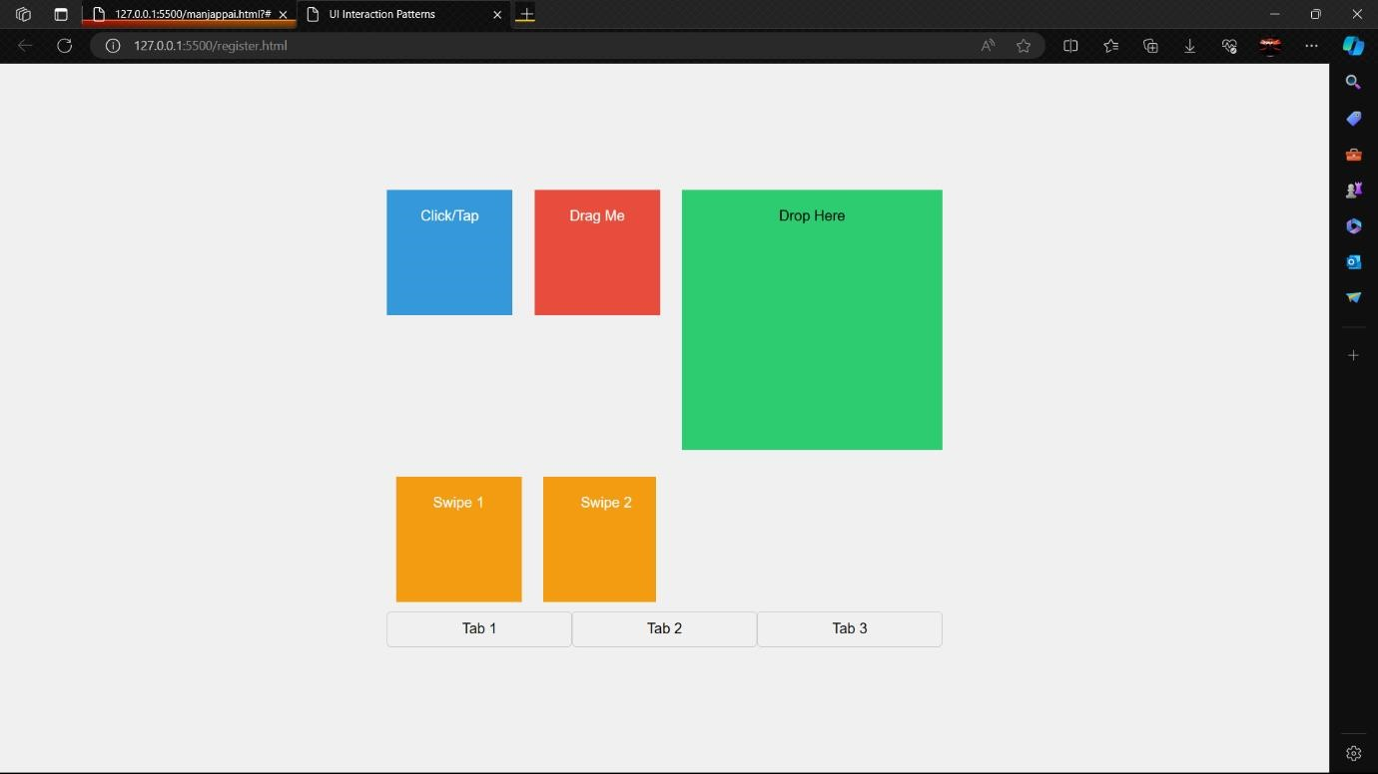

RESULT:
Thus the UI/UX program of UI Interaction pattern is verified and executed successfully.

EX.NO:3 DATE: | Developing an interface with proper UI Style Guides

AIM:
Creating a program with a proper UI style guide involves using HTML, CSS, and potentially JavaScript to ensure consistency and adherence to design principles. Below is a simple example that incorporates basic UI style guide elements. Note that this is a starting point, and you can expand and customize it based on your specific design requirements.

PROGRAM:
<!DOCTYPE html>
<html lang="en">
<head>
<meta charset="UTF-8">
<meta name="viewport" content="width=device-width, initial-scale=1.0">
<title>UI Style Guide Example</title>
<style> body {
font-family: 'Arial', sans-serif; line-height: 1.6;
background-color: #f5f5f5;
color: #333; margin: 0;
padding: 0;
}
/* Header Styles */ header { background-color: #3498db;
color: #fff; padding: 10px;
text-align: center;
}
/*
Navigation Styles */
nav {
background-color: #2c3e50; padding: 10px;
text-align: center;
} nav a { color: #fff; text-decoration: none; padding: 10px; margin: 0 10px; display: inline-block;
}
/* Main Content Styles */ .container { max-width: 800px; margin: 20px auto; padding: 20px; background-color: #fff; border-radius: 5px; box-shadow: 0 0 10px rgba(0, 0, 0, 0.1);
} h1, h2, h3 { color: #333;
}
p { margin-bottom: 20px;
}
/* Button Styles */
.btn {
background-color: #e74c3c;
color: #fff;
padding: 10px 20px;
text-decoration: none; border-radius: 3px; display: inline-block; transition: background-color 0.3s ease;
}
.btn:hover { background-color: #c0392b;
}
/* Form Styles */ form { margin-bottom: 20px;
} label { display: block; margin-bottom: 8px;
}
input[type="text"], input[type="email"], input[type="password"] { width: 100%; padding: 10px; margin-bottom: 10px; border: 1px solid #ccc; border-radius: 3px;
}
input[type="submit"] { background-color: #2ecc71;
color: #fff;
padding: 10px 20px; border: none; border-radius: 3px; cursor: pointer;
}
input[type="submit"]:hover { background-color: #27ae60;
}
/* Footer Styles */ footer {
background-color: #34495e;
color: #fff; padding: 10px; text-align: center; position: fixed; bottom: 0; width: 100%;
}
</style>
</head>
<body>
<header>
<h1>UI Style Guide Example</h1>
</header>
<nav>
<a href="#">Home</a>
<a href="#">About</a>
<a href="#">Services</a>
<a href="#">Contact</a>
</nav>
<div class="container">
<h2>Main Content Heading</h2>
<p>This is a simple example of a UI style guide. Feel free to customize and expand it based on your project requirements.</p>
<a href="#" class="btn">Call to Action</a>
<form>
<label for="name">Name:</label>
<input type="text" id="name" name="name" required>
<label for="email">Email:</label>
<input type="email" id="email" name="email" required>
<label for="password">Password:</label>
<input type="password" id="password" name="password" required>
<input type="submit" value="Submit">
</form>
</div>
<footer>
<p>&copy; 2024 UI Style Guide Example. All rights reserved.</p>
</footer>
</body>
</html>

OUTPUT:

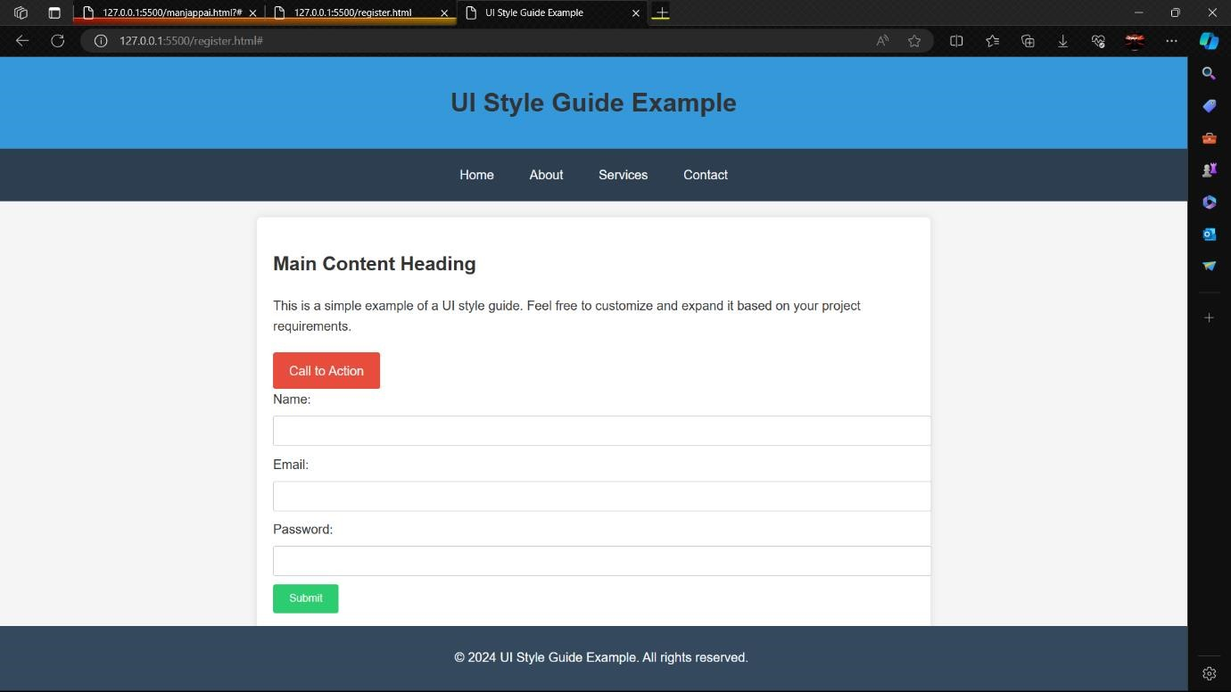

RESULT:
Thus the UI/UX program of UI styles guide is verified and executed Successfully.

EX.NO:4 DATE: | Developing Wire flow diagram for application using open-source software

AIM:
Creating a wireflow diagram involves combining wireframes and user flow diagrams to represent the structure and flow of a user interface. In this example, I'lldemonstrate using the open-source desktop application Pencil Project for creating a wireflow diagram.

Using Pencil Project:

1. Download and Install Pencil Project:
- Visit the Pencil Project GitHub Releases page.
- Download the latest version suitable for your operating system • (Windows, macOS, Linux).
- Install the application on your computer.

2. Open Pencil Project:
• the Pencil Project application.

3. Create a New Document:
- Click on "File" and select "New."
- Choose the type of document you want (e.g., Desktop or Mobile).

4. Add UI Components
- On the left toolbar, select the "Wireframe" category.
- Drag and drop UI components onto the canvas to represent screens or • components of your application.

5. Connect Components:
- Use connectors or arrows from the toolbar to represent the flow • between different screens or components.
- Connect the components to illustrate the user journey.

6. Label Components:
- Double-click on components to add labels and provide more
- information about each screen or component.

7. Group and Align:
- Group related components together to maintain a clean and organized • layout.
- Use alignment tools to ensure a consistent structure.

8. Add Annotations:
• Utilize the annotation feature to add notes or comments to specific • components, explaining functionality or user interactions.

9. Customize Styles:
• Customize the appearance of your wireflow by adjusting colors, fonts, • and other styling options.

10.Save Your Project:
• Click on "File" and choose "Save" to save your wireflow project for • future editing.

11.Export as Image or PDF:
- Once you're satisfied with your wireflow, you can export it as an • image (PNG, JPEG) or a PDF.
- Click on "File" and select "Export Document.

OUTPUT:
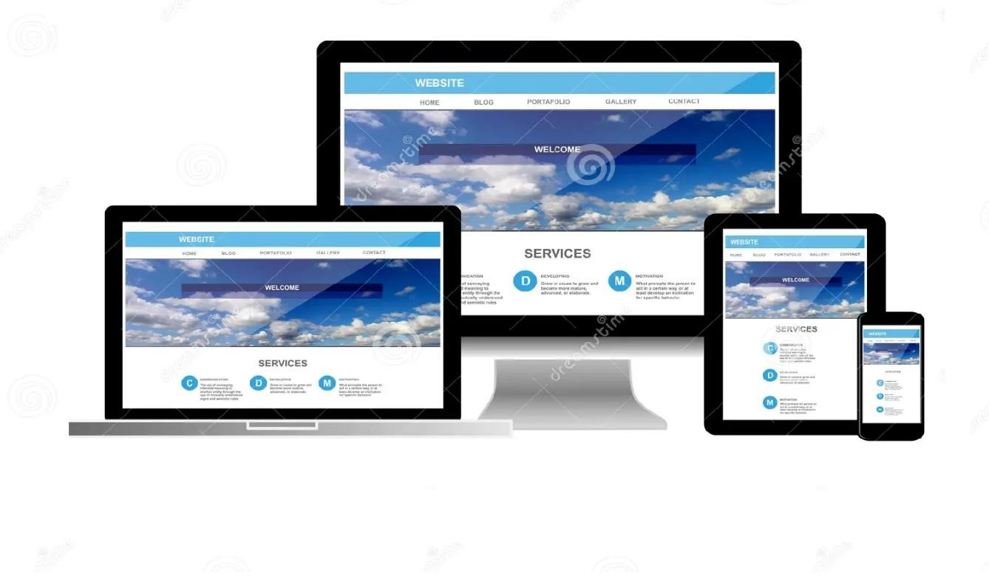

RESULT:
Thus the UI/UX program of wire flow application is verified and executed successfully.

EX.NO:5 DATE: | Exploring various open source collaborative interface Platform

AIM:
To evaluate and compare different open-source collaborative interface platforms in order to understand their features, functionality, ease of use, and suitability for various collaborative tasks.

PROGRAM:

HTML Code:
<!DOCTYPE html>
<html>
<body>
<h1>Colloborative Drawing</h1>
<canvas id="myCanvas" width="200" height="100" style="border:1px solid black;">
Sorry, your browser does not support canvas.
</canvas> <script>
const canvas = document.getElementById("myCanvas"); const ctx = canvas.getContext("2d"); ctx.fillStyle = "red"; ctx.fillRect(0,0,150,75);
</script>
</body>
</html>

OUTPUT:
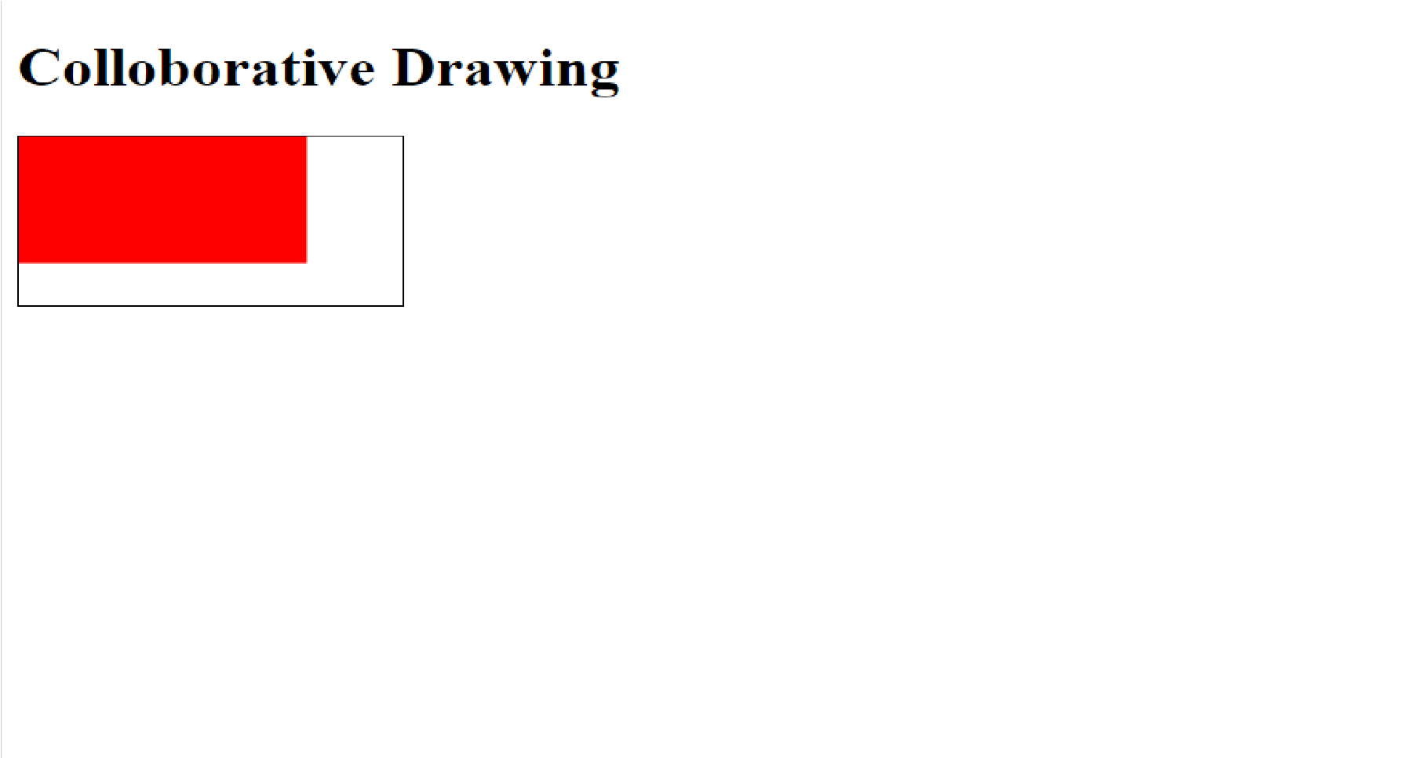

RESULT:
Thus the UI/UX program of collaborative open source interface platform is verified and executed Successfully.

EX.NO:6 DATE: | Hands on Design Thinking Process for a new product

AIM:
To guide participants through the design thinking process to develop a prototype for a new product that addresses a specific user need or pain point.

PROCEDURE:

1. Empathize:
- Understand the target user's needs, desires, and pain points through interviews, observations, and empathy exercises.
- Develop personas to represent different user segments and their unique characteristics.

2. Define:
- Synthesize the insights gathered during the empathize stage to define the core problem or opportunity statement.
- Reframe the problem statement in a human-centered and actionable manner.

3. Ideate:
- Generate a wide range of creative ideas and potential solutions to address the defined problem or opportunity.
- Encourage brainstorming sessions, idea generation techniques like mind mapping, and rapid prototyping.

4. Prototype:
- Translate selected ideas into tangible prototypes or mockups that represent potential solutions.
- Use low-fidelity prototyping tools like paper sketches or digital wireframes to quickly iterate on ideas.

5. Test:
- Gather feedback on the prototypes through user testing and evaluation.
- Validate assumptions, gather insights, and identify areas for improvement.

Activities:

1. Empathy Mapping:
- Conduct interviews or empathy exercises to understand users' needs, motivations, and pain points.
- Create empathy maps to visualize user perspectives and insights.

2. Problem Statement Workshop:
- Facilitate a workshop to define the problem statement based on the insights gathered.
- Use techniques like "How Might We" statements to reframe the problem in a user-centered way.

3. Ideation Session:
- Organize a brainstorming session to generate a diverse range of ideas.
- Encourage participants to think outside the box and defer judgment during idea generation.

4. Prototyping Sprint:
- Divide participants into teams and assign them to develop prototypes based on selected ideas.
- Provide prototyping tools and materials to facilitate rapid iteration and experimentation.

5. User Testing and Iteration:
- Conduct user testing sessions to gather feedback on the prototypes.
- Encourage participants to iterate on their prototypes based on user feedback and insights.

OUTPUT:
- Prototype(s):
  - Developed prototypes or mockups representing potential solutions to the identified problem or opportunity.
- User Feedback:
  - Insights and feedback gathered from user testing sessions to validate assumptions and refine prototypes.
- Iterative Design Process:
  - Experience participating in an iterative design process that emphasizes empathy, creativity, and user feedback.

RESULT:
Thus the UI/UX program of design thinking problem is verified and executed successfully.

EX.NO:7 DATE: | Brainstorming feature for proposed product

AIM:
To conduct a brainstorming session to generate innovative features for a proposed product, fostering creativity and collaboration among participants.

PROCEDURE:
- Identify User Needs:
  - Understand the target users' requirements, preferences, and pain points related to the proposed product.
  - Prioritize user needs and areas for improvement based on market research and user feedback.
- Generate Ideas:
  - Encourage participants to think creatively and generate a diverse range of feature ideas that address identified user needs.
  - Foster an open and inclusive brainstorming environment where all ideas are welcomed and explored.
- Evaluate and Prioritize:
  - Evaluate the feasibility, viability, and desirability of each proposed feature based on criteria such as market demand, technical feasibility, and business goals.
  - Prioritize feature ideas based on their potential impact, alignment with the product vision, and resource constraints.
- Refine and Define:
  - Refine selected feature ideas into well-defined user stories or feature specifications that clearly articulate the problem they address, the proposed solution, and the expected benefits.
Activities:
- User Needs Identification:
  - Review user research findings, market analysis, and customer feedback to identify key user needs and pain points.
  - Create user personas or empathy maps to represent different user segments and their specific requirements.
- Brainstorming Session:
  - Facilitate a brainstorming session where participants generate as many feature ideas as possible within a specified time frame.
  - Encourage participants to build on each other's ideas and explore unconventional solutions.
- Idea Evaluation and Prioritization:
  - Conduct a group discussion to evaluate the feasibility, desirability, and viability of each feature idea.
  - Use techniques like impact-effort matrix or weighted scoring to prioritize feature ideas based on predefined criteria.
- Feature Refinement:
  - Select the most promising feature ideas and refine them into actionable user stories or feature specifications.
  - Define clear objectives, success criteria, and acceptance criteria for each feature to guide implementation and evaluation.

OUTPUT:
- Feature Ideas:
  - Generated a diverse range of feature ideas that address user needs and enhance the proposed product's value proposition.
- Prioritized Feature List:
  - Identified and prioritized key features based on their potential impact, feasibility, and alignment with business objectives.
- Refined Feature Specifications:
  - Developed well-defined user stories or feature specifications for selected features, providing clear guidance for implementation and evaluation.

RESULT:
Thus the UI/UX program of brainstorming problem is verified and executed successfully.

EX.NO:8 DATE: | Defining the Look and Feel of the new project

AIM:
Defining the look and feel of a new project involves creating a cohesive and visually appealing identity that aligns with the project's goals and resonates with the target audience. Here are step-by-step guidelines to help you in this process:

PROGRAM:

HTML CODE
<!DOCTYPE html>
<html lang="en">
<head>
<meta charset="UTF-8">
<meta http-equiv="X-UA-Compatible" content="IE=edge">
<meta name="viewport" content="width=device-width, initial-scale=1.0">
<title>New Project</title>
<link rel="stylesheet" href="styles.css">
</head>
<body>
<header>
<h1>Welcome to the New Project</h1>
</header>
<main>
<p>This is where the main content goes.</p>
</main>
<footer>
<p>&copy; 2023 New Project</p>
</footer>
</body>
</html>

CSS
/* styles.css */ body { font-family: Arial, sans-serif; margin: 0; padding: 0;
}
header { background-color: #333;
color: #fff; text-align: center; padding: 10px 0;
}
main { padding: 20px;
}
footer { background-color: #333; color: #fff; text-align: center; padding: 10px 0;
}

OUTPUT:
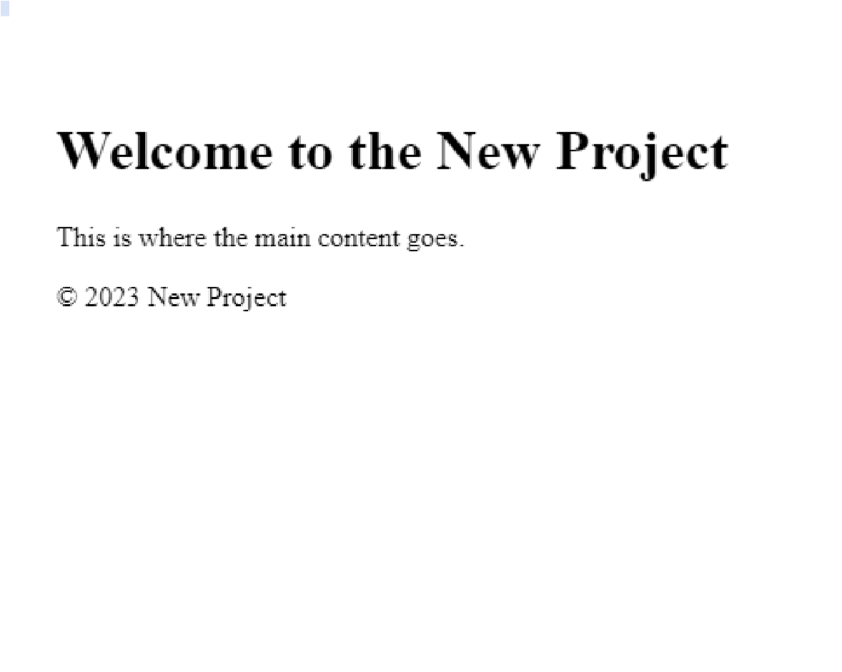

RESULT:
Thus the UI/UX program of look and feel of product is verified and executed successfully.

EX.NO:9 DATE: | Create a Sample Pattern Library for that product  (Mood board, Fonts, Colours based on UI principles)

AIM:
To create a comprehensive Sample Pattern Library for [product name], integrating Mood boards, Fonts, and Colors based on fundamental UI principles. This exercise aims to provide a structured framework for consistent design elements, facilitating cohesive visual communication and enhancing user experience across the product interface.

PROGRAM:

HTML CODE:
<!DOCTYPE html>
<html lang="en">
<head>
<meta charset="UTF-8">
<meta http-equiv="X-UA-Compatible" content="IE=edge">
<meta name="viewport" content="width=device-width, initial-scale=1.0">
<title>Product Pattern Library</title>
<link rel="stylesheet" href="styles.css">
</head>
<body>
<h1>Mood Board:</h1>
<div class="mood-board">
<p>playing chess</p>
<p>Watching movie</p>
<p>Reading books</p>
<!-- Mood board content here -->
</div>

<h2>Fonts:</h2>
<div class="fonts">
<p style="font-family:algerian">Hello world</p>
<p style="font-family:broadway">welcome</p>
<!-- Fonts information here -->
</div>
<h2>Colors:</h2>
<div class="colors">
<p style="color:red">red</p>
<p style="color:blue">blue</p>
<p style="color:green">green</p>
<!-- Colors palette here -->
</div>
</body>
</html> CSS: body {
font-family: Arial, sans-serif; background-color: #f0f0f0; margin: 0; padding: 0;
}
header { background-color: #333; color: white;
text-align: center; padding: 10px 0;
}
footer { background-color: #333; color: white; text-align: center; padding: 10px 0; position: fixed; bottom: 0; width: 100%;
}

OUTPUT:
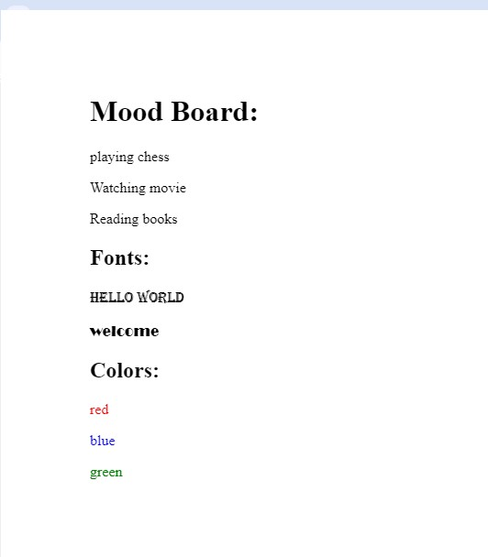

RESULT:
Thus the UI/UX program of Sample pattern Library is verified and executed successfully

EX.NO:10 DATE: | Identify a customer problem to solve

AIM:
To Identify a Customer Problem to Solving Customer Problem with Responsive Design.

PROGRAM:

HTML CODE:
<!DOCTYPE html>
<html lang="en">
<head>
<meta charset="UTF-8">
<meta name="viewport" content="width=device-width, initial-scale=1.0">
<title>Responsive Design</title>
<style> body {
font-family: Arial, sans-serif; margin: 0; padding: 0;
background-color: #f0f0f0;
}
.container { max-width: 1200px; margin: 0 auto; padding: 20px; display: flex; justify-content: center; align-items: center; height: 100vh;
}
.content { background-color: #fff; padding: 20px; border-radius: 5px; box-shadow: 0 2px 5px rgba(0, 0, 0, 0.1);
}
@media (max-width: 768px) {
.content { padding: 10px;
}}
</style>
</head>
<body>
<div class="container">
<div class="content">
<h1>Welcome to Our Website</h1>
<p>Providing solutions to your problems.</p>
</div>
</div>
</body>
</html>

OUTPUT:
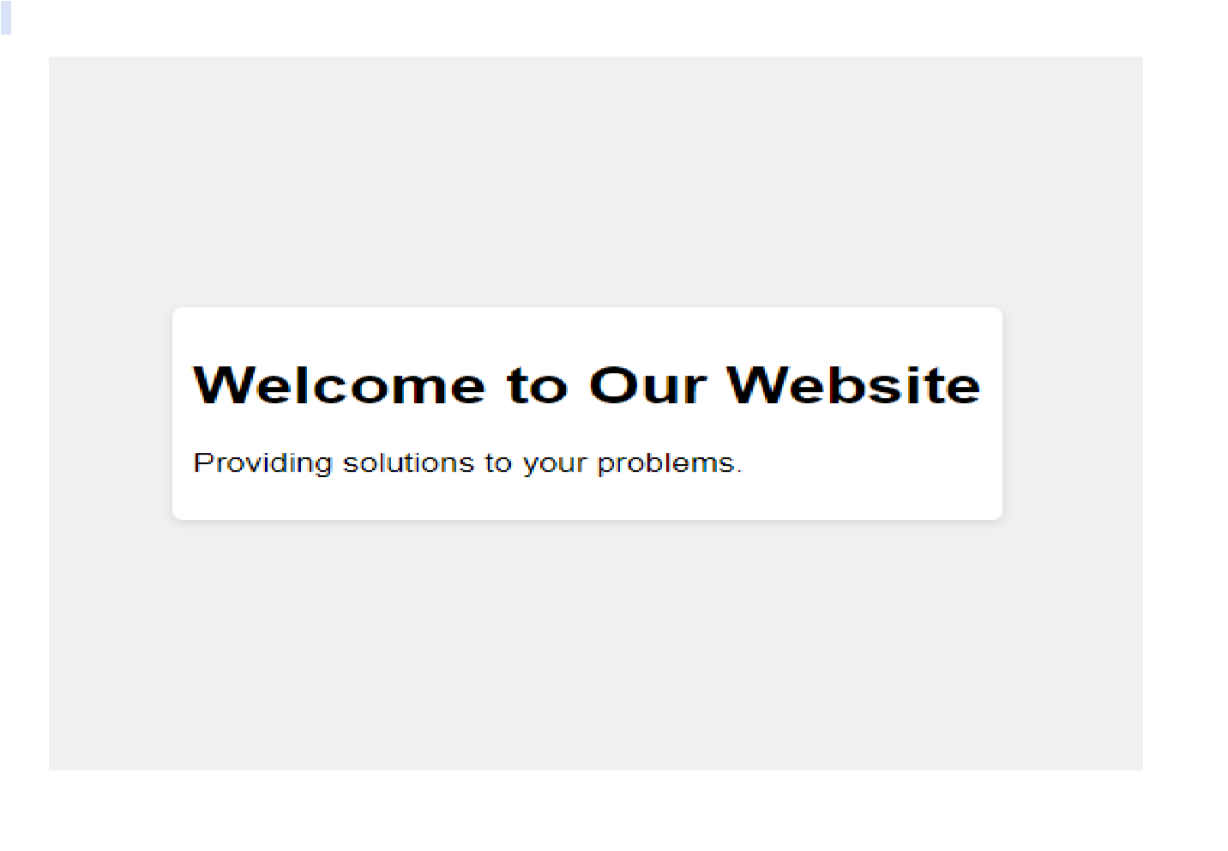

RESULT:
Thus the UI/UX program of customer problem to solve Responsive design is verified and executed successfully.

EX.NO:11 DATE: | Conduct end-to-end user research - User research, creating personas, Ideation process (User stories,  Scenarios), Flow diagrams, Flow Mapping

AIM:
To conduct comprehensive user research and ideation process, including the creation of personas, user stories, scenarios, flow diagrams, and flow mapping, in order to gain deep insights into user needs and behaviors, and to develop a user-centered solution that addresses those needs effectively.
PROGRAM:

HTML CODE:
<!DOCTYPE html>
<html>
<head>
<title>User Research and Ideation Process</title>
<style>
/* CSS for flow diagrams */
.flow-diagram { width: 100%; height: auto; border: 2px solid #333; padding: 20px; margin: 20px 0;
}
/* CSS for personas */
.persona {
background-color: #f9f9f9; border: 1px solid #ccc; padding: 10px;
margin: 10px 0;
}

/* CSS for user stories */ .user-story { font-style: italic; color: #555;
}
</style>
</head>
<body>
<h1>User Research and Ideation Process</h1>
<div class="flow-diagram">
<h2>Flow Diagram</h2>
<!-- Insert flow diagram content here -->
</div
<div class="personal">
<h2>Personal</h2>
<!-- Insert persona content here -->
</div>
<div class="user-story">
<h2>User Stories</h2>
<!-- Insert user stories content here -->
</div>
</body>
</html>

OUTPUT:
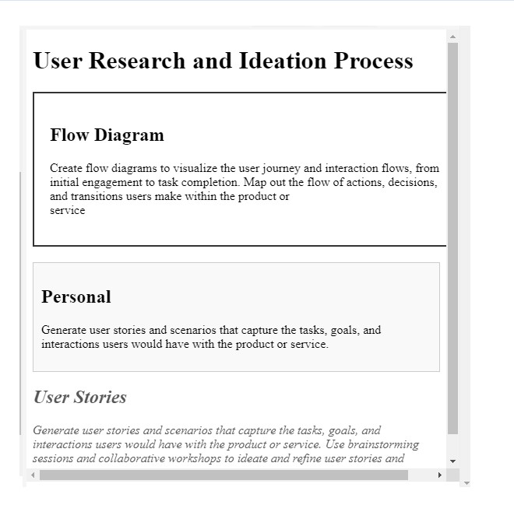

RESULT:
Thus the UI/UX program of End-to-End User Research is verified and executed successfully

EX.NO:12 DATE: | Sketch, design with popular tool and build a prototype and perform usability testing and identify  improvements

AIM:
To develop a user-centered prototype by sketching, designing with popular tools, and conducting usability testing in order to identify areas for improvement and enhance the overall user experience of the product or service.
PROGRAM: HTML CODE
<!DOCTYPE html>
<html lang="en">
<head>
<meta charset="UTF-8">
<meta http-equiv="X-UA-Compatible" content="IE=edge">
<meta name="viewport" content="width=device-width, initial-scale=1.0">
<title>Prototype</title>
<link rel="stylesheet" href="styles.css">
</head>
<body>
<header>
<h1>Prototype Design</h1>
</header>
<section>
<p>Welcome to our prototype!</p>
</section>
<footer>
<p>&copy; 2023 Prototype Inc.</p>
</footer>
</body>
</html> CSS: body { font-family: Arial, sans-serif; background-color: #f0f0f0; margin: 0; padding: 0;
}
header { background-color: #333; color: white; text-align: center; padding: 10px 0;
}
footer { background-color: #333; color: white; text-align: center; padding: 10px 0; position: fixed; bottom: 0; width: 100%;
}

OUTPUT:
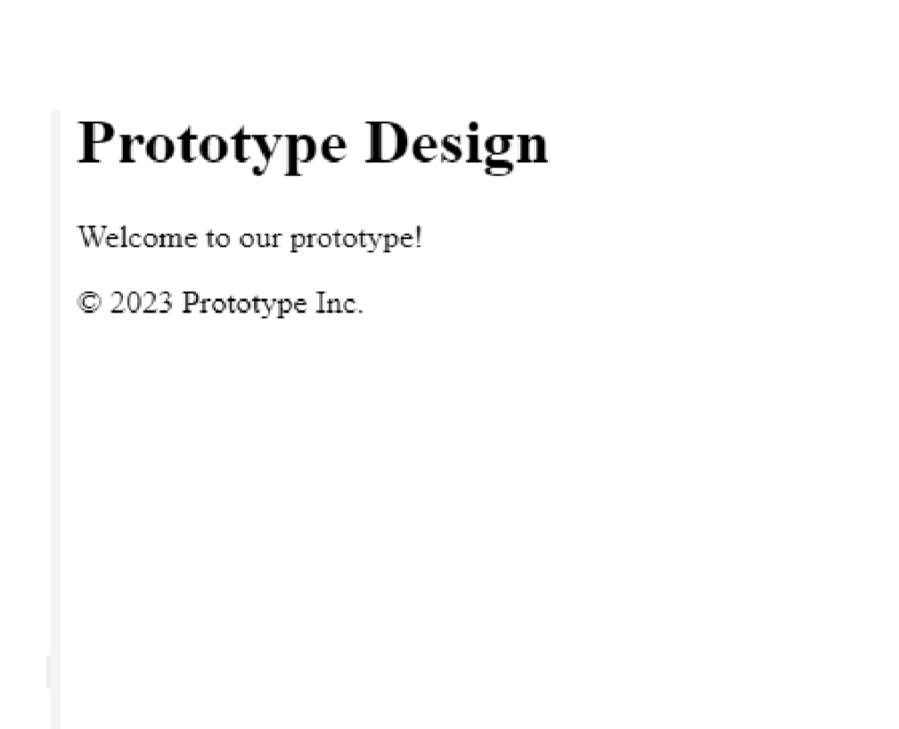

RESULT:
Thus the UI/UX program of design with popular tool and build prototype is verified and executed successfully

